**March Offerings**

Mar 07 Local Combined Budget

Mar 14 AWR/ Hope Channel*

Mar 21 Local Combined Budget

Mar 28 Mich. Advance Partners

**March Birthdays**

01 Herbert Smith

09 Candice Benson

09 Rhianna Ruger

19 Carolyn Trickey

21 Staci Carter

23 Margaret Peck

25 Tom Rhodes

eliz

Holt

Seventh-day Adventist

Church

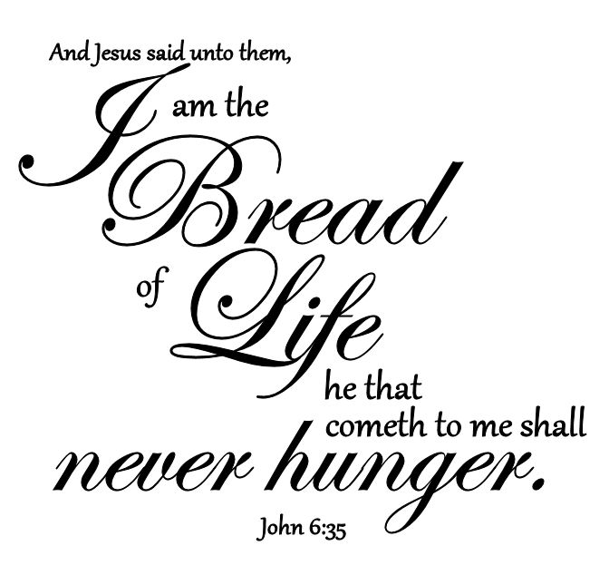

PRAYER REQUESTS FOR THIS WEEK

* For Revival & Reformation & the Holy Spirit to be poured out.
* Our mission outreach to Holt, Dimondale, Mason & South Lansing.
* Our Pastor and his family.
* Our Church Budget.
* **Our Building Committee as we study growing our church building.**

**______________________**

**Psalm 95:6**

O come, let us worship and bow down:

Let us kneel before the Lord our Maker.

O come, let us worship and bow down:

Let us kneel before the Lord our Maker.



Please take a moment to fill out our guest information card and place in the offering plate when it's passed around.

Date: ______________________

Name: _____________________

Email: _____________________

Phone: _____________________

Address: ____________________

___________________________

___________________________

Please send me information on:

* Pastor Visit
* Baptism
* Bible Studies
* Care Groups
* Membership Transfer
* Youth Programs

Calendar of Events

**Mar 14, Sab Welcome and Happy Sabbath**

**Mar 14, Sab Church Potluck, Everyone is Welcome**

**Elders Meeting- March 25th -6:00pm**

**Church Board Meeting- March 25th – 6:30pm**

**Mar 10th , Tues- Prayer Meeting @ 6:30pm/ “Unto A Perfect Man Bible Study”** will be held at 7:00pm

**Healthy Lifestyles: Getting Every Bite Right** Friday, March 13th @ 8:30 here at the church!

**Country Life Order** will go **in March 30th** and will need to be ***picked up on*****April *9th***. Please contact Anna Petty for any questions.

**Church Cleaning Bee here at the Church on March 22nd at 9am.** Please contact Gail Dick for details.

There is a **CARE Group Coordinating Committee Meeting** after potluck on Sabbath, March 14th .

**CARE Group Host Meeting** will be on March 16th at 6:30pm here at the Church

**_____________________________________________________________________**

**-----------------------------------------------------------------------------------------------------------------------------------------------------------------------**

**Holt Seventh-day Adventist Church**

**March 14 , 2020**

**Song Service begins at 9:30** Oliver & Ladine Samuels

**Announcements** Stephen Dick

**WORSHIP TIME – 9:45**

**Welcome** Stephen Dick

**Invocation** **Pastor Hanlon**

**Call to Worship Come, Thou Fount of Every Blessing #** 334

**Offering** Everett Kittleson

**Children’s Story Pastor Hanlon**

**Prayer** Stephen Dick

**Scripture Reading** John 6:35-37Stephen Dick

**Special Music** Oliver Samuels

**Sermon "** Jesus Teaches on Righteousness, Pt. 1**" Pastor Hanlon**

**Consecration Hymn** I Love to Tell the Story  **#457**

**Benediction Pastor Hanlon**

**SABBATH SCHOOL - 11:30AM**

**11:30 - 12:30**

**Pastor Chuck Hanlon, (517)507-4196 Email:** chanlon@misda.church

**Organ/Piano: Betty Breakey / Corina Nephew** [](http://www.facebook.com/HoltSDAChurch)

ON DUTY

**Elder in charge:** Stephen Dick

**Deacon on Duty:** Tom Rhodes

**Bulletin: E-mail-** silversaph@hotmail.com/Text to 517-667-4535 by Wednesday 12pm

Other: ______________________________________________________

_______________________________________________________________________________________________________________________________________________________________________________________________________________________________________________________________________________________________________

Pray for:

* Salvation
* Finances
* Physical Healing
* Emotional Healing
* Commitment
* Peace, Patience
* Employment
* Guidance
* Relationships
* Family
* Encouragement

**Prayer Requests:** Ask and You Shall Receive ~Matthew 7:7



**Church Phone: (517) 699-8550 Email: Holtsdachurch94@hotmail.com**

**Church Address: 5682 Holt Rd, Holt MI 48842**

**Sabbath Ends Today:7:44pm Sabbath Begins Next Friday:7:51pm**